import javax.swing.JOptionPane;

public class Customer\_Finance {

public static void main(String[] args) {

// TODO Auto-generated method stub

//two objects . first with interest and second with no interest

Finance\_Period a=new Finance\_Period();

a.setCustomerName();

a.setContactNumber();

a.setProductPrice();

a.setNumberOfMonths();

a.calculate\_repayment();

display\_info(a);

Finance\_Period b=new Finance\_Period();

b.setCustomerName();

b.setContactNumber();

b.setProductPrice();

b.setNumberOfMonths();

b.calculate\_repayment();

display\_info(b);

}

//displaying message box

public static void display\_info(Customer c)

{

String info=String.format("Customer name:%s \n contact Number: %d \n product price: %f \n repayment months: %f\n monthly repayment %f\n total due: %f\n",c.customerName,c.contactNumber,c.productPrice,c.numberOfMonths,c.monthlyRepaymentAmount,c.monthlyRepaymentAmount\*c.numberOfMonths);

JOptionPane.showMessageDialog(null, info);

}

}

------------

import javax.swing.JOptionPane;

public class Customer {

//variables for storing customer data

String customerName;

int contactNumber;

double productPrice;

double numberOfMonths;

double monthlyRepaymentAmount;

//getter and setter

public String getCustomerName() {

return customerName;

}

public void setCustomerName() {

this.customerName = JOptionPane.showInputDialog("please enter customer name: ");

}

public int getContactNumber() {

return contactNumber;

}

public void setContactNumber() {

this.contactNumber = Integer.parseInt(JOptionPane.showInputDialog("please enter contact number: "));

}

public double getProductPrice() {

return productPrice;

}

public void setProductPrice() {

this.productPrice = Double.parseDouble(JOptionPane.showInputDialog("please enter product price: "));

}

public double getNumberOfMonths() {

return numberOfMonths;

}

public void setNumberOfMonths() {

this.numberOfMonths = Double.parseDouble(JOptionPane.showInputDialog("please enter number of months: "));

}

public void calculate\_repayment()

{

System.out.print("hello");

monthlyRepaymentAmount=productPrice/numberOfMonths;

}

}

-------------------

public class Finance\_Period extends Customer {

//if months<=3 no interest or else interest

@Override

public void calculate\_repayment() {

// TODO Auto-generated method stub

if(numberOfMonths<=3)

{

monthlyRepaymentAmount=productPrice/numberOfMonths;

}

else

{

double interest= (25.0/100.0) \* productPrice;

double amount=productPrice + interest;

monthlyRepaymentAmount=amount/numberOfMonths;

}

}

}

------------

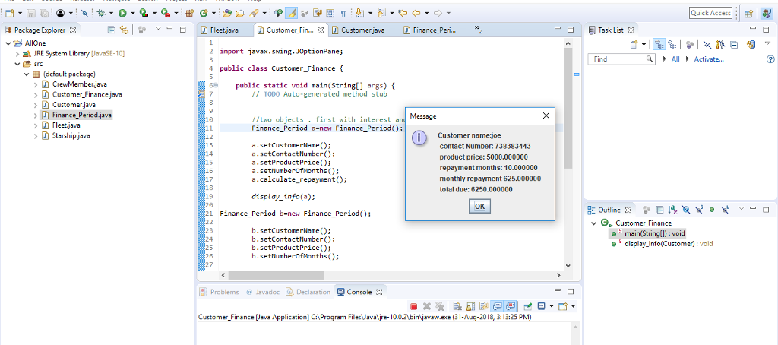

Question 2

* import java.util.ArrayList;

import java.util.Arrays;

import java.util.List;

import java.util.Scanner;

public class Scrabble {

static String name1;

static String name2;

static int score1=0;

static int score2=0;

static String alpha="a b c d e f g h i j k l m n o p q r s t u v w x y z";

static List<String> alphabets=new ArrayList<String>(Arrays.asList(alpha.split(" ")));

public static void main(String[] args) {

System.out.println("Welcome to WORD WARDS game");

System.out.println("\nPress (1) to start the game.");

System.out.println("\nPress any other key to exit the game");

System.out.print("Enter your selection: ");

System.out.println("\*\*\*\*\*\*\*\*\*\*\*\*\*\*\*\*\*\*\*\*\*\*\*\*\*\*\*\*\*\*\*\*\*\*\*");

Scanner sc=new Scanner(System.in);

String choice=sc.nextLine();

if(!choice.equals("1"))

System.exit(0);

else {

System.out.print("Enter player 1 name: ");

name1=sc.nextLine();

System.out.print("Enter player 2 name: ");

name2=sc.nextLine();

boolean flag=true;

String input="";

while(!input.equals("???")) {

displayLetters();

if(flag) {

System.out.print(name1+" enter your word: ");

input=sc.nextLine();

if(!input.equals("???"))

System.out.println("Enter y if both agree to the word");

String yes=sc.nextLine();

flag=false;

while(!validateWord(input) || !yes.equalsIgnoreCase("y")) {

System.out.println("YOU ENTERED WORD THAT CONTAINS LETTER THAT IS NOT PRESENT OR BOTH PLYERS DID NOT AGREE! PLEASE ENTER ANOTHER");

System.out.print(name1+" enter your word: ");

input=sc.nextLine();

if(input.equals("???"))

break;

System.out.println("Enter y if both agree to the word");

yes=sc.nextLine();

}

if(!input.equals("???"))

score1+=input.length();

removeLetter(input);

}else {

flag=true;

System.out.print(name2+" enter your word: ");

input=sc.nextLine();

if(!input.equals("???"))

System.out.println("Enter y if both agree to the word");

String yes=sc.nextLine();

while(!validateWord(input) || !yes.equalsIgnoreCase("y")) {

System.out.println("YOU ENTERED WORD THAT CONTAINS LETTER THAT IS NOT PRESENT OR BOTH PLYERS DID NOT AGREE! PLEASE ENTER ANOTHER");

System.out.print(name2+" enter your word: ");

input=sc.nextLine();

if(input.equals("???"))

break;

System.out.println("Enter y if both agree to the word");

yes=sc.nextLine();

}

if(!input.equals("???"))

score2+=input.length();

removeLetter(input);

}

}

if(score1>score2)

System.out.println("Winner of the game is: "+name1+" with score of: "+score1);

else if(score2>score1)

System.out.println("Winner of the game is: "+name2+" with score of: "+score2);

else

System.out.println("Match Tie");

}

}

public static boolean validateWord(String word) {

for (char ch : word.toCharArray()) {

if (!alphabets.contains(String.valueOf(ch)))

return false;

}

return true;

}

public static void removeLetter(String s) {

for (char ch : s.toCharArray()) {

alphabets.remove(String.valueOf(ch));

}

}

public static void displayLetters() {

System.out.print("Alphabet letters left: ");

for (String string : alphabets) {

System.out.print(string+" ");

}

System.out.println();

}

public static String menu() {

return null;

}

}

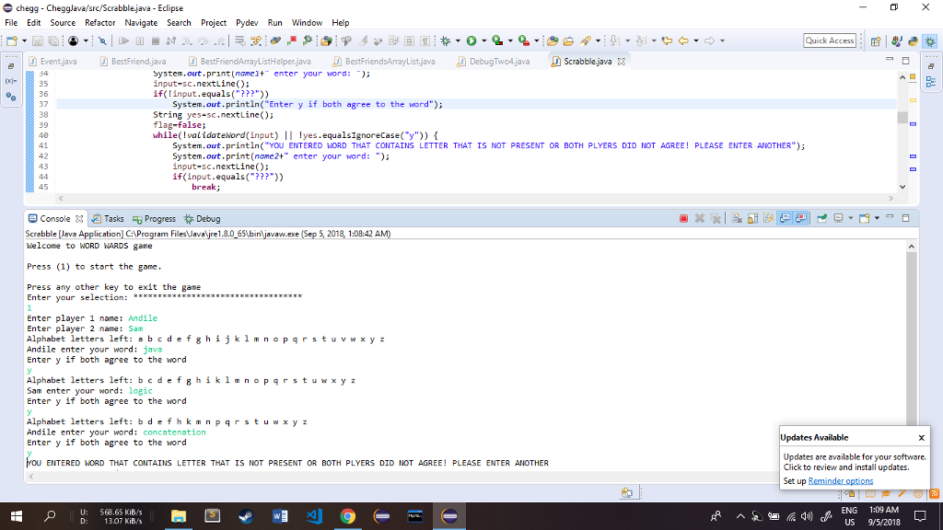

[Comment](https://www.chegg.com/homework-help/questions-and-answers/software-development-house-work-decided-create-prototype-based-game-scrabble-twist-used-mo-q30794462)

Practice with similar questions

[Q:](https://www.chegg.com/homework-help/questions-and-answers/software-development-house-work-decided-create-prototype-based-game-scrabble-twist-used-mo-q55866666" \t "_blank)

[java language](https://www.chegg.com/homework-help/questions-and-answers/software-development-house-work-decided-create-prototype-based-game-scrabble-twist-used-mo-q55866666" \t "_blank)

[A:](https://www.chegg.com/homework-help/questions-and-answers/software-development-house-work-decided-create-prototype-based-game-scrabble-twist-used-mo-q55866666" \t "_blank)

[See answer](https://www.chegg.com/homework-help/questions-and-answers/software-development-house-work-decided-create-prototype-based-game-scrabble-twist-used-mo-q55866666" \t "_blank)

[Q:](https://www.chegg.com/homework-help/questions-and-answers/question-2-marks-65-software-development-house-work-decided-create-prototype-based-game-sc-q55994671" \t "_blank)

[please help with this Java programming question](https://www.chegg.com/homework-help/questions-and-answers/question-2-marks-65-software-development-house-work-decided-create-prototype-based-game-sc-q55994671" \t "_blank)

[A:](https://www.chegg.com/homework-help/questions-and-answers/question-2-marks-65-software-development-house-work-decided-create-prototype-based-game-sc-q55994671" \t "_blank)

[See answer](https://www.chegg.com/homework-help/questions-and-answers/question-2-marks-65-software-development-house-work-decided-create-prototype-based-game-sc-q55994671" \t "_blank)

[Show more](https://www.chegg.com/homework-help/questions-and-answers/software-development-house-work-decided-create-prototype-based-game-scrabble-twist-used-mo-q30794462)

Questions viewed by other students

[Q:](https://www.chegg.com/homework-help/questions-and-answers/learning-area-inheritance-question-1-create-class-named-customer-determine-monthly-repayme-q30757116" \t "_blank)

[Write in Java and the third picture must be follow](https://www.chegg.com/homework-help/questions-and-answers/learning-area-inheritance-question-1-create-class-named-customer-determine-monthly-repayme-q30757116" \t "_blank)

[A:](https://www.chegg.com/homework-help/questions-and-answers/learning-area-inheritance-question-1-create-class-named-customer-determine-monthly-repayme-q30757116" \t "_blank)

[See answer](https://www.chegg.com/homework-help/questions-and-answers/learning-area-inheritance-question-1-create-class-named-customer-determine-monthly-repayme-q30757116" \t "_blank)

[100% (3 ratings)](https://www.chegg.com/homework-help/questions-and-answers/learning-area-inheritance-question-1-create-class-named-customer-determine-monthly-repayme-q30757116" \t "_blank)

[Q:](https://www.chegg.com/homework-help/questions-and-answers/hey-please-help-question-2-programming-language-jave-please-code-full-question-copy-paste--q55423795" \t "_blank)

[hey can you please help with question 2 the programming language is jave please code the full question so that i can copy and paste in in netbeans   i hope you can help me please](https://www.chegg.com/homework-help/questions-and-answers/hey-please-help-question-2-programming-language-jave-please-code-full-question-copy-paste--q55423795" \t "_blank)

[A:](https://www.chegg.com/homework-help/questions-and-answers/hey-please-help-question-2-programming-language-jave-please-code-full-question-copy-paste--q55423795" \t "_blank)

[See answer](https://www.chegg.com/homework-help/questions-and-answers/hey-please-help-question-2-programming-language-jave-please-code-full-question-copy-paste--q55423795" \t "_blank)

[100% (3 ratings)](https://www.chegg.com/homework-help/questions-and-answers/hey-please-help-question-2-programming-language-jave-please-code-full-question-copy-paste--q55423795" \t "_blank)

[Show more](https://www.chegg.com/homework-help/questions-and-answers/software-development-house-work-decided-create-prototype-based-game-scrabble-twist-used-mo-q30794462)

Post a question

Answers from our experts for your tough homework questions

Top of Form

Continue to post

18 questions remaining

Bottom of Form

My Textbook Solutions

Instant access to step-by-step solutions for your textbooks

Question 2

import java.util.Scanner;

public class Scramble {

   public static void main(String[] args) {  
        
       // Scanner to take user inputs  
       Scanner scan = new Scanner(System.in);  
        
       // Variable declaration  
       String playerOne = "";  
       String playerTwo = "";  
       String word = "";  
       int pOnePoint = 0, pTwoPoint = 0;  
       boolean end = true, pOneTurn = true, disagree = false, valid = true;  
       char alphabets[] = {'a','b','c','d','e','f','g','h','i','j','k'  
               ,'l','m','n','o','p','q','r','s','t','u','v','w','x','y','z'};  
       boolean alphabetsUsed[] = new boolean[26];  
        
       // Initializing all the values in array to false as no characters are used yet  
       for(int i = 0; i < 26; i++) {  
           alphabetsUsed[i] = false;  
       }  
        
       // Welcome Screen  
       System.out.println("Welcome to the WORD WARS game.\n");  
       System.out.println("Press (1) To start the game.\n");  
       System.out.println("Press any other key to exit the game");  
       System.out.print("Enter your selection: ");  
        
       // If user wants to play it takes the user input for names  
       if(scan.next().equals("1")) {  
           System.out.println("\*\*\*\*\*\*\*\*\*\*\*\*\*\*\*\*\*\*\*\*\*\*\*\*\*\*\*\*\*\*\*\*\*\*\*\*\*\*\*\n");  
           System.out.print("Enter player 1 name: ");  
           playerOne = scan.next();  
           System.out.print("Enter player 2 name: ");  
           playerTwo = scan.next();            
       }else {  
           System.exit(0);  
       }  
        
       // Real game begins  
       System.out.println("\nLETS PLAY WORD WARS!!!");  
       do {  
           end = true;  
            
           // Prints the remaining characters to the screen  
           System.out.print("Alphabet letters left: ");  
           for(int i = 0; i < 26; i++) {  
               if(alphabetsUsed[i] == false) {  
                   System.out.print(alphabets[i]+" ");  
               }  
           }  
           System.out.println();  
            
           // Asks the player whose turn it is to enter the word  
           if(pOneTurn == true) {  
               System.out.print(playerOne+" enter your word: ");  
               pOneTurn = false;  
           }else {  
               System.out.print(playerTwo+" enter your word: ");  
               pOneTurn = true;  
           }  
            
           // Loops below will take use input and make sure that the word enterd is a valid word  
               // This loop just below will loop untill both users are satisfied with the word  
           do {  
                
               // This loop just below will loop untill the word entered is invalid  
               do {  
                    
                   // If the word entered first time is invalid it asks the appropriate user to enter it again  
                   if(valid == false|| disagree == true) {  
                       if(pOneTurn == false ) {  
                           System.out.print(playerOne+" enter your word: ");  
                       }else {  
                           System.out.print(playerTwo+" enter your word: ");  
                       }  
                   }  
                   valid = true;  
                    
                   // Takes user input for word  
                   word = scan.next();  
                    
                   // If user cannot come up with any more words and want to quit then this comes into action  
                   if(word.equals("???")) {  
                       if(pOnePoint > pTwoPoint) {  
                           System.out.println("WINNER OF THE GAME IS: "+playerOne+" with a score of: "+pOnePoint);  
                           System.out.println("YOUR NAME HAS BEEN SAVED TO HALL OF FAME!!!");  
                       }else if(pOnePoint < pTwoPoint){  
                           System.out.println("WINNER OF THE GAME IS: "+playerTwo+" with a score of: "+pTwoPoint);  
                           System.out.println("YOUR NAME HAS BEEN SAVED TO HALL OF FAME!!!");  
                       }else if(pOnePoint == pTwoPoint) {  
                           System.out.println("IT'S A DRAW!!");  
                       }  
                       System.out.println("THE GAME IS NOW OVER. THANKYOU FOR PLAYING WORD WARS!!!");  
                       System.exit(0);  
                   }  
                    
                   // Checks weather word enterd by user is valid or not  
                   for(int i = 0; i < word.length(); i++) {  
                       for(int j = 0; j < 26; j++) {  
                           if(word.charAt(i) == alphabets[j]) {  
                                
                               // If it finds a character that is already used then it marks that word as invalid and breaks out  
                               if(alphabetsUsed[j] == true) {  
                                   System.out.println("YOU ENTERED A WORD THAT CONTAINS A LETTER THAT IS USED OR IN NOT VALID,"  
                                           + " PLEASE ENTER ANOTHER WORD!");  
                                   valid = false;  
                                   break;  
                               }  
                           }  
                       }  
                        
                       // If word is invalid then there is no point in continuing so it jumps out  
                       if(valid == false) {  
                           break;  
                       }  
                   }  
               }while(valid == false);  
                
               disagree = true;  
               System.out.println("Enter (y) yes if both players agree on the word");  
               // Asks for the agreement of both the users  
           }while(!scan.next().equals(String.valueOf('y')));  
            
           disagree = false;  
            
           // If valid word is enterd then the players points are incremented by 1 for each letter in the word  
           if(pOneTurn == false) {  
               pOnePoint += word.length();  
           }else {  
               pTwoPoint += word.length();  
           }  
            
           // Sets the indexe of the alphabetsUsed array to true at the index of every character other than vowels in the word  
           for(int i = 0; i < word.length(); i++) {  
               for(int j = 0; j < 26; j++) {  
                   if(word.charAt(i) == alphabets[j]) {  
                       if(word.charAt(i) != 'a' && word.charAt(i) != 'e' && word.charAt(i) != 'i' &&  
                               word.charAt(i) != 'o' && word.charAt(i) != 'u') {  
                           alphabetsUsed[j] = true;  
                       }  
                   }  
               }  
           }  
            
           // Checks to see if there are only vowels left, if so then it concludes the end of the game  
           for(int j = 0; j < 26; j++) {  
               if(alphabetsUsed[j] == false){  
                   if(alphabets[j] != 'a' && alphabets[j] != 'e' && alphabets[j] != 'i' &&  
                           alphabets[j] != 'o' && alphabets[j] != 'u') {  
                       end = false;  
                       break;  
                   }  
               }  
           }  
            
           // If it is the end then the winner is displayed on the console  
           if(end == true) {  
               if(pOnePoint > pTwoPoint) {  
                   System.out.println("WINNER OF THE GAME IS: "+playerOne+" with a score of: "+pOnePoint);  
                   System.out.println("YOUR NAME HAS BEEN SAVED TO HALL OF FAME!!!");  
               }else if(pOnePoint < pTwoPoint){  
                   System.out.println("WINNER OF THE GAME IS: "+playerTwo+" with a score of: "+pTwoPoint);  
                   System.out.println("YOUR NAME HAS BEEN SAVED TO HALL OF FAME!!!");  
               }else if(pOnePoint == pTwoPoint) {  
                   System.out.println("IT'S A DRAW!!");  
               }  
               System.out.println("THE GAME IS NOW OVER. THANKYOU FOR PLAYING WORD WARS!!!");  
           }  
       }while(end == false);  
        
       // Scanner object is closed to avoid leakage  
       scan.close();  
   }

}

Question 2

import java.util.\*;

public class Scrabble

{

public static void main(String[] args) {

int i, index;

int player1Score = 0;

int player2Score = 0;

boolean playerSelect = true; //true means first player

String word = " "; // the players enter into this variable

Scanner sc = new Scanner(System.in);

System.out.println("Welcome to the WORLD WARS game");

System.out.println("\nPress (1) To start the game");

System.out.println("\nPress (any other key to exit the game");

System.out.println("Enter your selection");

if(sc.nextInt() != 1) {

System.out.println("Stopping the game");

System.exit(0);

}

System.out.println("\*\*\*\*\*\*\*\*\*\*\*\*\*\*\*\*\*\*\*\*\*\*\*\*\*\*\*\*\*\*\*\*\*\*\*\*\*\*\*\*\*\*\*\*\*\*\*\*\*\*\*\*\*\*\*\*\*\*\*\*\*\*\*\*\*\*");

System.out.println("\nPress (any other key to exit the game");

//Read details of the players

System.out.print("Enter player 1 name : ");

String player1 = sc.next();

System.out.print("Enter player 2 name : ");

String player2 = sc.next();

String alphabets = "abcdefghijklmnopqrstuvwxyz";

System.out.println("LETS PLAY WORD WARS!!!");

//Print the alphebats with spaces

while(true) {

System.out.print("Alphabet letters left : ");

for(i = 0;i<alphabets.length();i++) {

System.out.print(" "+alphabets.charAt(i));

}

//Select which palyer to play, using the variable playerSelect

if(playerSelect) {

playerSelect = false;

System.out.print("\n"+player1);

}

else {

playerSelect = true;

System.out.print("\n"+player2);

}

System.out.print(" enter your word: ");

word = sc.next();

if(word.equals("???")) { //stopping condition

break;

}

System.out.println("Enter (y) yes if both players agree on the word ");

char opt = sc.next().charAt(0);

if(opt !='y') {

playerSelect = !playerSelect;

continue;

}

int validWord = 1; //now the word is valid when the value is 1

// travers through the word and find if all letters are in the alphabets

for(i=0;i<word.length();i++) {

if(alphabets.contains(String.valueOf((word.charAt(i))))) {

validWord = 1;

}

else {

validWord = 0;

break;

}

}

// if the letter contains invalid alphabets ask to enter again

if(validWord == 0) {

System.out.println("YOU ENTERED A WORD THAT CONTAINS A LETTER THAT IS USED OR IS NOT VALID. PLEASE ENTER ANOTHER WORD");

playerSelect = !playerSelect; //Change the chance of the player again to same person

//continue to loop

continue;

}

//if it is valid , remove each letter from the alphabets which are in the variable word

//Add the score for the current player

if(!playerSelect == true) {

//If it is the player 1

player1Score = player1Score + word.length();

}

else {

player2Score = player2Score + word.length();

}

for(i=0;i<word.length();i++) {

if(alphabets.contains(String.valueOf(word.charAt(i)))) { //this checking is necessary to avoid exception , when multiple letters are ther

index = alphabets.indexOf(word.charAt(i)); // find the index of the particular character in the alphabets

// remove that char from the alphabet

alphabets = alphabets.substring(0, index) + alphabets.substring(index + 1);

}

}

} //end of while loop, means game stops

//check the winner.

System.out.print("WINNER OF THE GAME IS : ");

if(player1Score > player2Score) {

System.out.println(player1+" with a score of : "+player1Score);

}

else {

System.out.println(player2+" with a score of : "+player2Score);

}

System.out.println("YOUR NAME HAS BEEN SAVED TO THE HALL OF FAME!!!");

System.out.println("THE GAME IS NOW OVER. THANKYOU FOR PLAYING WORD WARS!!!");

}

}